US Year 11 CIE – Pre-test
20 Questions | 60 minutes | Calculator allowed
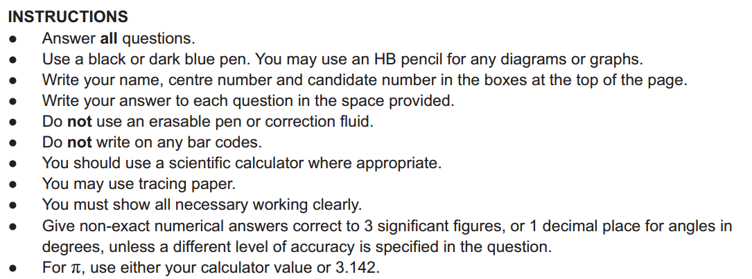

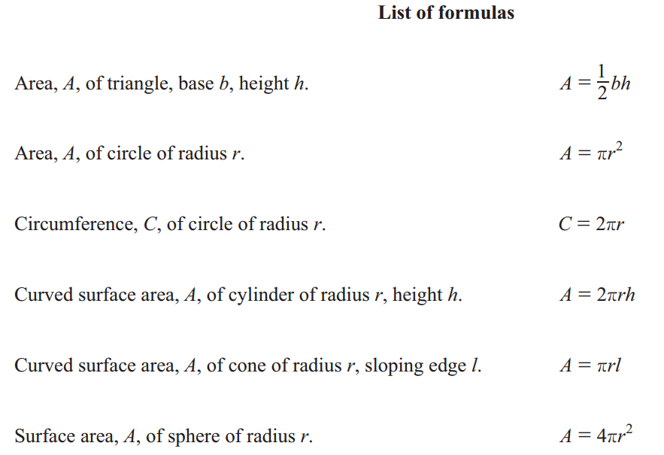
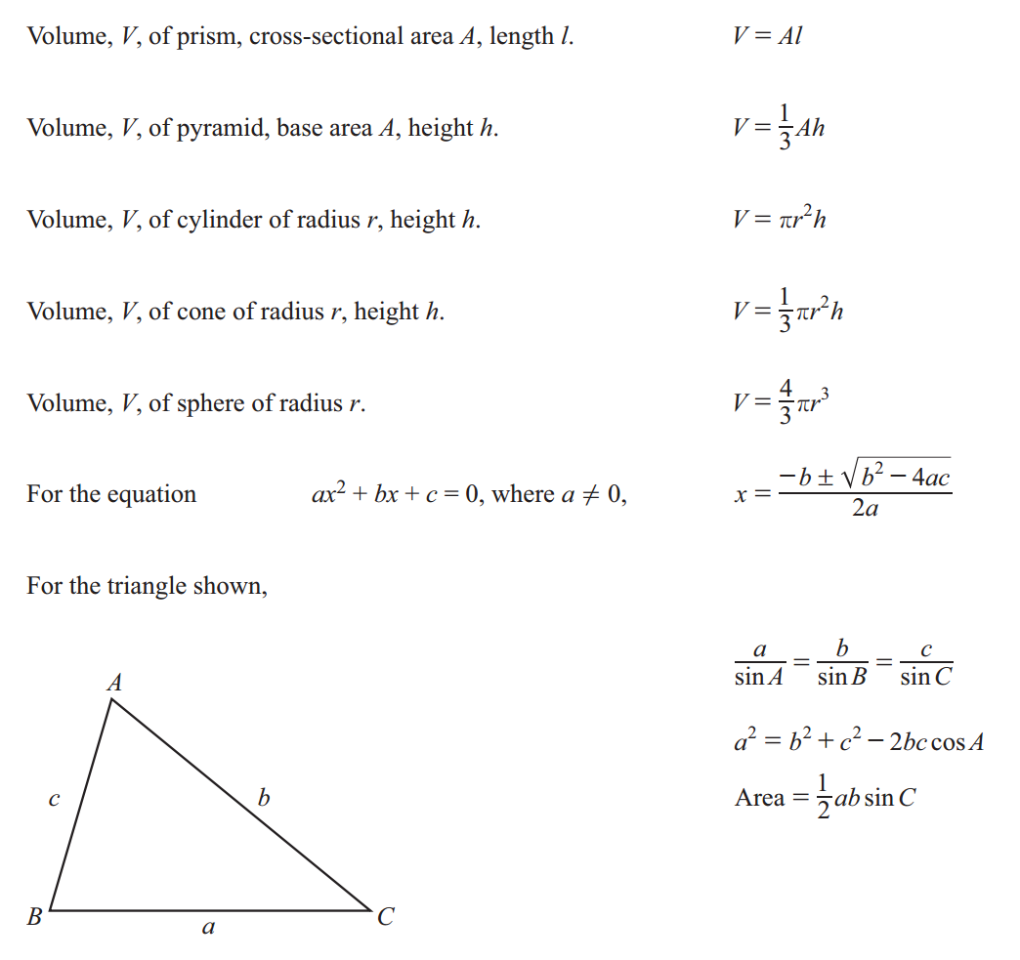
1. Mass of box A : Mass of box B = 4 : 7
The mass of box B is 2.4 kg more than the mass of box A.
Calculate the mass of box A and the mass of box B.

Box A______________________kg
Box B______________________kg

2. A solid wooden cone has base radius 4cm and height 12cm.
The density of the wood is $0.74 g/cm^{3}$
Calculate the mass of the cone.
[Density = Mass $÷$ Volume]

______________________g

3. Solve the simultaneous equations.
You must show all your working.
$2w-3y=11$
$3w+y=11$

$w=$______________________
$y=$______________________
4. In a sale, the original price of a shirt is reduced by 15%.
The sale price of the shirt is $23.63 .
Find the original price of the shirt.

$_________________________

5. The length of a rectangle is 16cm, correct to the nearest centimetre.
The width of the rectangle is 14cm, correct to the nearest centimetre.
Calculate the lower bound of the perimeter of the rectangle.

_________________________cm

6. Triangle ABC and triangle PQR are mathematically similar.
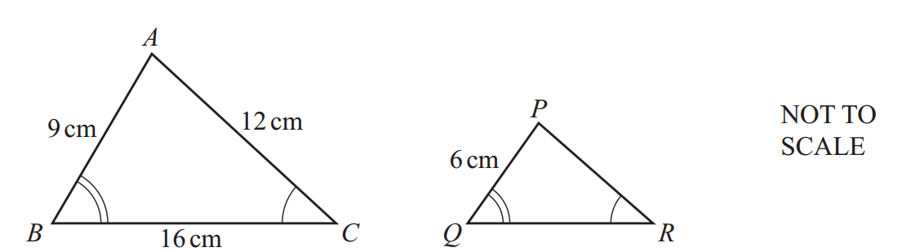

Triangle ABC and triangle PQR are the cross-sections of two prisms.
These prisms are mathematically similar.
The volume of the smaller prism is 1120 $cm^{3}$
Calculate the volume of the larger prism.

_________________________$cm^{3}$
7. The interior angle of a regular polygon is 172°.
Find the number of sides of this polygon.

_________________________
8. On any day, the probability that the weather will be sunny is 0.7 .

When the weather is sunny, the probability that Rohit goes for a walk is 0.9 .
When the weather is not sunny, the probability that Rohit goes for a walk is 0.2 .
Find the probability that on any day Rohit goes for a walk.

_________________________

9. Bobbie invests $500 in an account that pays compound interest each year.
At the end of 17 years, the value of Bobbie’s investment is $700.13 .
Find the value of Bobbie’s investment at the end of 20 years.

$_________________________
10.
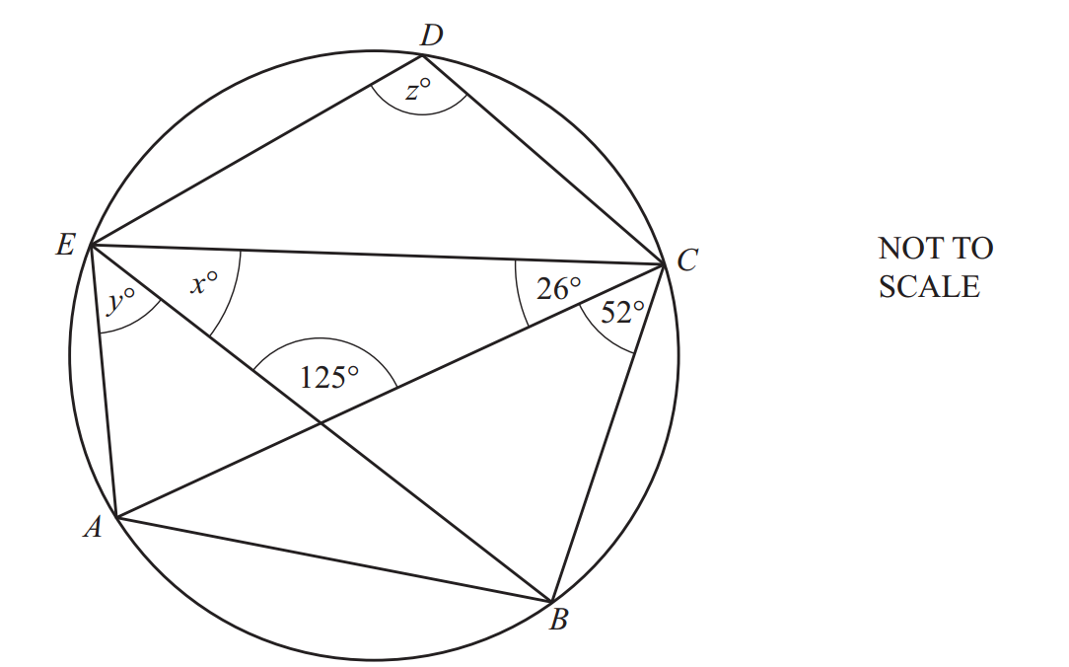
$A, B, C, D$ and $E$ lie on a circle.
Find the values of $x,y$ and$z$

$x=$_________________________
$y=$_________________________
$z=$_________________________

11. $f(x)=x+1$ $g(x)=5-2x$ $h(x)=2^{x}$
- $f(-3)$

_________________________
- $fg(1)$

_________________________
- Find $x$ when $h(x)=1$

$x=$_________________________
- Find $x$ when $h^{-1}(x)=3$

$x=$_________________________

12.
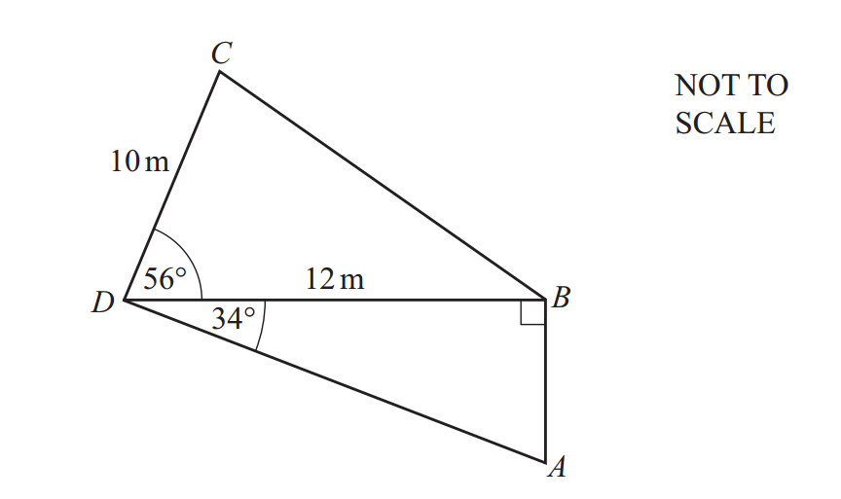
The diagram shows a quadrilateral ABCD.
CD = 10m and DB = 12m.
Angle DBA = 90°, angle CDB = 56° and angle ADB = 34°

Calculate the perimeter of the quadrilateral ABCD

_________________________$m^{2}$

13. Simplify.
$(64u^{36})^{\frac{5}{6}}$

_________________________ $g/s$

14.
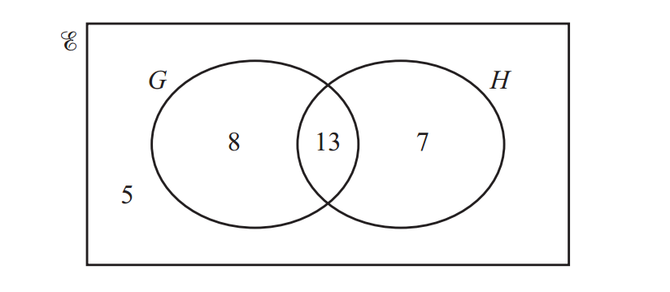
$ξ$ = {number of students in a class}
G = {number of students who study geography}
H = {number of students who study history}
The Venn diagram shows information about the 33 students in a class.

Two of the students who study history are picked at random.
Find the probability that one student also studies geography
and one student does not study geography.

_________________________________
15. Simplify.
$\frac{h^{2}+4h}{h^{2}-16}$

_________________________
16. Ahmed walks 2km at a speed of $x$ km/h.
He then walks a further 3km at a speed of $(x+1)$ km/h.
The total time he takes to walk the 5km is 1$\frac{1}{4}$ hours.
Show that $5x^{2}-15x-8=0$

17. P is the point (8,0) and Q is the point (20,6).
Find the equation of the perpendicular bisector of PQ.
Give your answer in the form$y=mx+c$

$y=$_________________________

18. $y=ax^{11}+3x^{b}$
$\frac{dy}{dx}=44x^{10}+18x^{c}$
Find the values of $a, b,$ and $c$

$a=$_________________________
$b=$_________________________
$c=$_________________________
19..
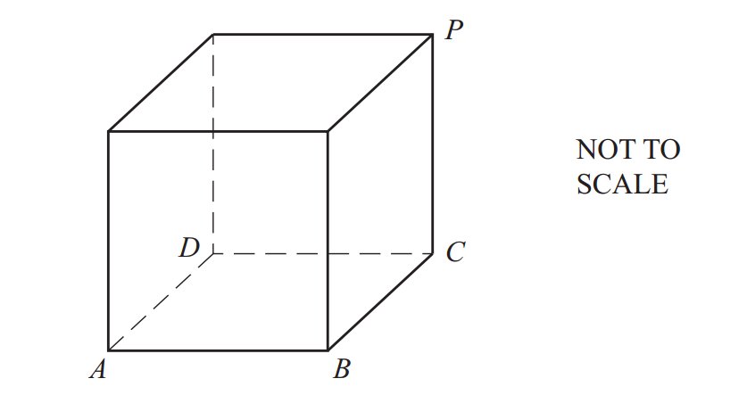
The diagram shows a cube.
Calculate the angle between the diagonal AP and the base ABCD.

_________________________

